**Pylint Installation:**

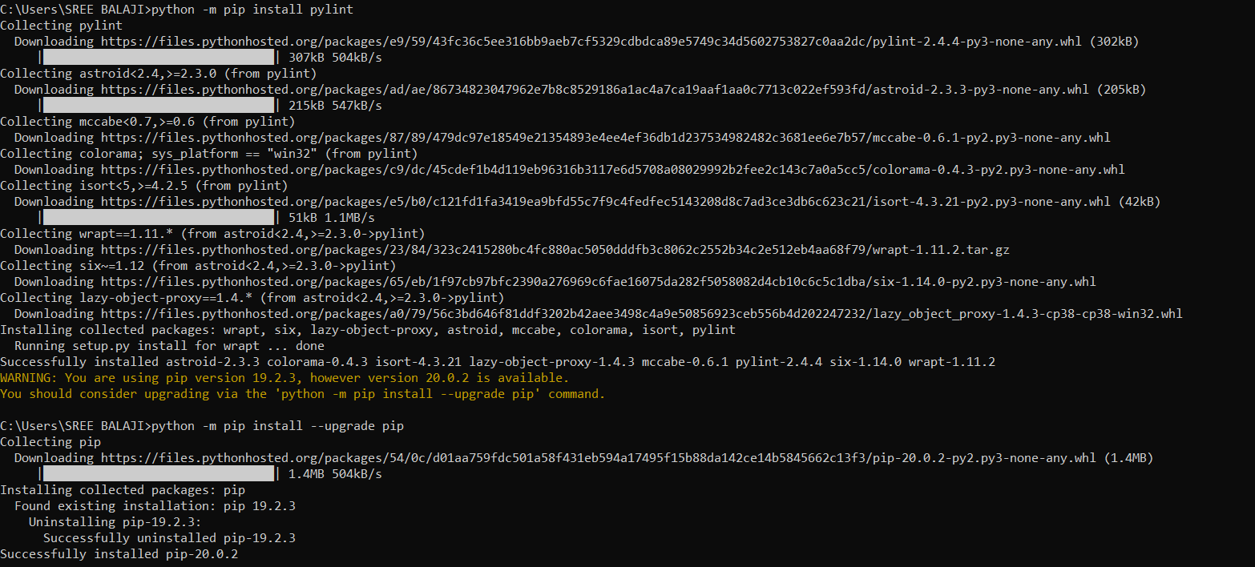

**Python code running through pylint:**

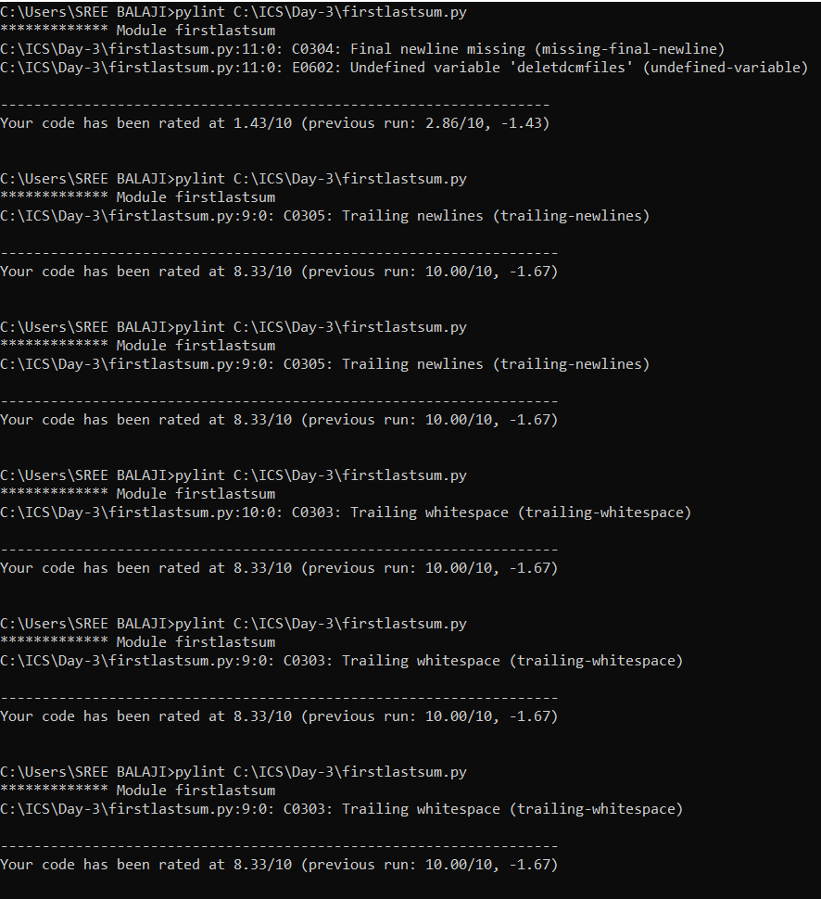

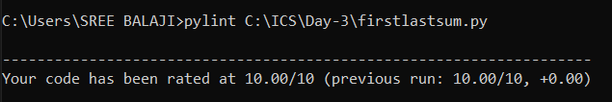

* At first running the python file through pylint, I got the score of 1.43/10 due to missing of line after the program and undefined variables and not given the white spaces clearly
* After identifying the errors, I cleared that, after running that again in the pylint I got 8.33/10 due to trailing spaces
* Here I got confused run the code several times
* After finding the error, I corrected it and executed the code and got a score 10/10